**Дата**: 8.05.2025

**Клас**: 5-Б

**Предмет**: англійська мова

**Тема:** Урок граматики. Сполучники підрядності.

**Мета:** формувати навички вживання лексичних одиниць по темі; удосконалювати навички читання, аудіювання й усного монологічного мовлення; розвивати пізнавальні інтереси учнів; виховувати інтерес до самостійного пошуку потрібної інформації, а також загальну культуру учнів.

**Вчитель**: Руда Д.В.

Хід уроку

1.Greeting

Good afternoon, guys! I’m pickled pink to see you. Are you ready to start our lesson? All set?

2. Повторення

Повторити Irregular verbs .

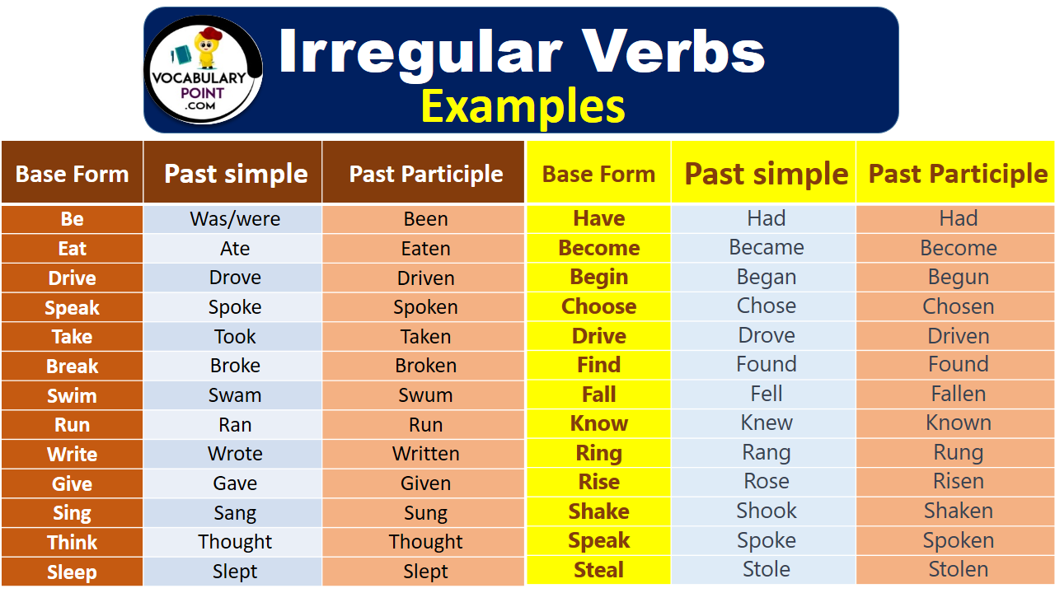

***Вивчити словник (бути готовим до слоникового диктанту) :***

*Careful-обережно (кеафул)*

*Slippery-слизько (сліпері)*

*To put on- одягати (пут он)*

*Overcast: covered with clouds; no sun is visible.- похмуро, сонця нема (овекаст)*

*"Under the weather": feeling ill or in low spirits. (e.g., "I'm feeling a bit under the weather today, so I'll stay home from work.")- мати погане самопочуття ( анде за везе)*

.

*Drizzle-мряка(дрізл)*

*Showers- a [short](https://dictionary.cambridge.org/dictionary/english/short" \o "short) [period](https://dictionary.cambridge.org/dictionary/english/period" \o "period) of [rain](https://dictionary.cambridge.org/dictionary/english/rain" \o "rain) or [snow](https://dictionary.cambridge.org/dictionary/english/snow" \o "snow)*

*Downpour- a lot of [rain](https://dictionary.cambridge.org/dictionary/english/rain" \o "rain) in a [short](https://dictionary.cambridge.org/dictionary/english/short" \o "short) [time](https://dictionary.cambridge.org/dictionary/english/time" \o "time) (дайн пор)*

*Flood-повінь(флад)*

*Hail-град(хейл)*

*Sleet-мокрий сніг(сліт)*

*Snowflake-сніжинка(сноуфлейк)*

*Blizzard-хуртелиця (блізард)*

*Mild: moderate in temperature; neither hot nor cold- помірний, м’який (майлд)*

*"Every cloud has a silver lining": every bad situation has some positive aspect to it. (e.g., "I lost my job, but I found a better one soon after. Every cloud has a silver lining.")- нема лиха без добра( ідіома)*

*To expect-очікувати(експект)*

*To report-повідомити(ріпот)*

*Chilly-прохолодний(чілі)*

*To get cold-холоднішати*

*It`s raining cats and dogs-сильно дощити (ідіома)*

*They cancelled the football game because it was raining cats and dogs.*

3. Wаrm up / Listening

Уважно слухати аудіо трек і дати відповідь на питання вчителя <https://www.youtube.com/watch?v=t9lAjCqxvPQ> .

4. Speaking

Are you afraid of going abroad alone?

Could you live in another country for the rest of your life?

Describe the most interesting person you met on one of your travels.

What was your best trip.

What was your worst trip.

Did your class in high school go on a trip together?

If so, where did you go?

How long did you stay?

How did you get there?

Do you have a driver's license?

Do you like to travel with children? Why or why not?

Do you like to travel with your mother? Why or why not?

Do you prefer summer vacations or winter vacations?

Do you prefer to travel alone or in a group? Why?

Do you prefer to travel by train, bus, plane or ship?

Do you prefer traveling by car or by plane?

Have you ever been in a difficult situation while traveling?

Have you ever been on an airplane?

How many times?

What airlines have you flown with?

Have you ever been to a foreign country?

Have you ever gotten lost while traveling? If so, tell about it.

Have you ever hitchhiked? If so, how many times?

Have you ever taken a package tour?

How do you spend your time when you are on holiday and the weather is bad?

How many countries have you been to? How many states?

How many times have you traveled abroad?

How much luggage do you usually carry?

5. Writing

Повторення Linking words.

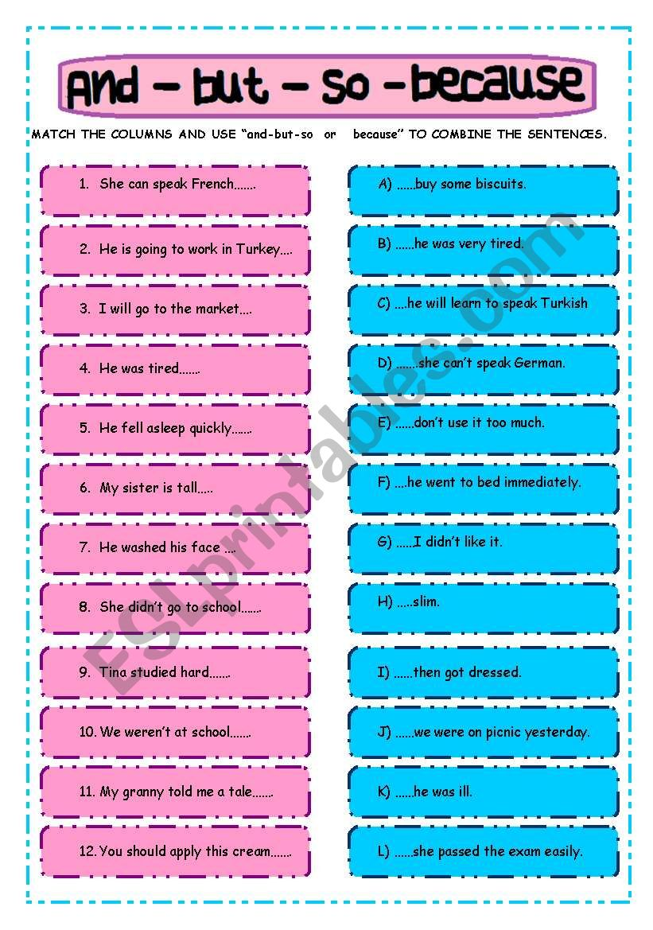

Виконати усно вправи.

<https://wordwall.net/uk/resource/61549894/%d0%b0%d0%bd%d0%b3%d0%bb%d1%96%d0%b9%d1%81%d1%8c%d0%ba%d0%b0-%d0%bc%d0%be%d0%b2%d0%b0/nationalities-and-contries>

<https://wordwall.net/uk/resource/34414727/%d0%b0%d0%bd%d0%b3%d0%bb%d1%96%d0%b9%d1%81%d1%8c%d0%ba%d0%b0-%d0%bc%d0%be%d0%b2%d0%b0/countries-and-nationalities>

<https://wordwall.net/ru/resource/23845014/spotlight-5-unit-2a-countries-and-nationalities>

Виконати вправу на робочому аркуші <https://www.liveworksheets.com/w/en/english-second-language-esl/1143658#google_vignette>

Опрацювати текст <https://en.islcollective.com/english-esl-worksheets/grammar-topic/should-shouldnt/travelling/138707> (речі, які ти не повинен робити коли подорожуєш)

6. Homework

1. Виконати письмово вправу 1 стр 132.

2. Повторити слова у словнику.